Casey Gray

ITEC3250

Assignment 3

100 pts

Due 10/1

Dr. Jonathan Jenkins
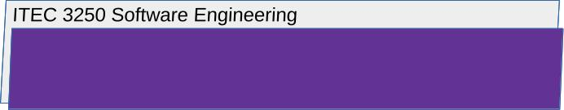

Requirements

1 Notes
- Number your responses as in the writeup, whether response is included or not
- To assist me in efficient scoring, use this document as a template, typing in your responses to each question.
- Your attention to detail in fully answering and exploring the question (without adding filler) will determine your score

What to Submit
lastnameFirstinitialA3.docx

All submitted files must be named with your first and last name as shown

2 Part 1

Answer the Following Questions

Architectural Design

- Choose and identify a particular software application, and argue which architectural pattern or patterns ( MVC, layered, client-server, repository, or pipe-filter) you believe are the best ones to capture the architecture of the application

Remember to consider how the components of the application would work together .For example, if the major components/parts in the system would work in layers, consider the layered architecture. If the application runs on a client device that communicates with a server to carry out major tasks, consider the client/server architecture.

- I’ve chosen Notepad++ as my software application. Although it is open source and has evolved over time, using multiple patterns, such as layered, client/server, etc, I believe that a layered architectural pattern would best capture the base application’s architecture. Since its focus is providing a simple text editor, we can break the application down into three distinct layers: the Presentation Layer, the Logic Layer, and the Data Layer. The presentation layer handles the UI, such as the menus, toolbars, and the text editing area itself. The logic layer is where the application’s main functionality is. It covers things like opening, saving, and formatting text, syntax, and search functions. Finally, the data layer handles file management, user preferences, and other data that is persistent across separate application uses.

There are several advantages to using layered architecture. First, changes to one layer can occur without affecting the other layers. This makes the application easier to maintain. This also means that the application is easily scalable. New features can be added without affecting other layers. Finally, it provides a separation of concerns between the different layers.

